Q1. Explain Single source shortest path [2 Marks]

Q2. What is Minimum Cost Spanning Tree? Explain Kruskal’s Algorithm and Find MST of the Graph. Also write its Time-Complexity. [10 marks]

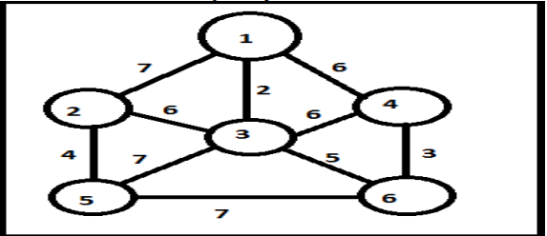

Q3. Explain Convex –Hull problem. [10 Marks]

Q4. Find the shortest path in the below graph from the source vertex 1 to all other vertices by using Dijkstra’s algorithm. [10 Marks]

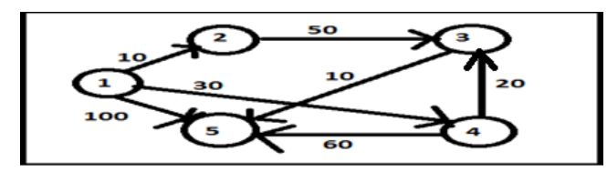

Q5. Given the six items in the table below and a Knapsack with Weight 100, what is the solution to the Knapsack problem in all concepts. I.e. explain greedy all approaches and find the optimal solution. [10 Marks]

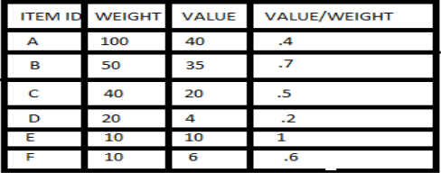

Q6. What do you mean by convex hull? Describe an algorithm that solves the convex hull problem. Find the time complexity of the algorithm. [7 Marks]

Q7. Compare the various programming paradigm such as divide and conquer, dynamic programming and greedy approach. [7 Marks]

Q8. Define spanning tree. Write Kruskal’s algorithm for finding minimum cost spanning tree. Describe how Kruskal’s algorithm is different from Prim’s algorithm for finding minimum cost spanning tree. [7 Marks]

Q9. What are greedy algorithm Explain their Characteristics. [2 Marks]

Q10. Define Feasible and optimal Solution. [2 Marks]

Q11. Briefly exaplin the Prim’s Algorithm. [2 Marks]

Q12. Define priniciple of Optimality. [2 Marks]

Q13. Write short note on Dijkstra’s algorithm shortest paths problems. [10 Marks]

Q14. State Bellman Ford algorithm. [10 Marks]

Q15. Consider the following instance for simple knapsack problem. Find the solution using greedy method. [10 Marks]

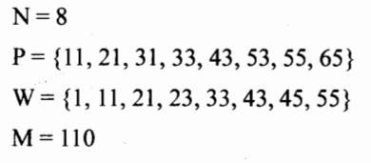

Q16. When do Dijkstra and Bellman-Ford algorithm both fail to find a shortest path? Can Bellman Ford detect all negative weight cycles in a graph? Apply Bellman Ford Algorithm on the following graph. Where A is the starting vertex. [7 Marks]

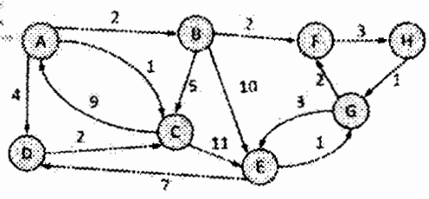

Q17. Given an integer x and a positive number n , use divide and conquer approach to write a function that computes xn with time complexity O(logn). [7 Marks]

Q18. 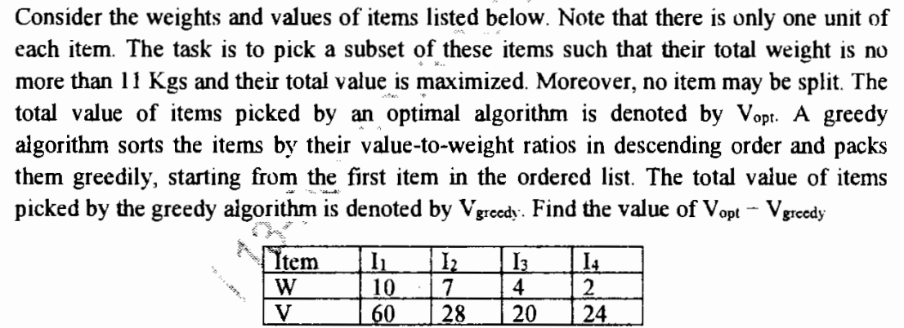[7 Marks]

Q19. Compare adjacency matrix and linked Adjacency lists representation of a graph with suitable example/ diagram. [10 Marks]

Q20. Explain “greedy algorithm” Write its pseudo code to prove that fractional Knapsack problem has a greedy-choice property. [10 Marks]

Q21. What are single source shortest paths? Write down Dijkstra’s algorithm for it. [10 Marks]

Q22. Prove that if the weights on the edge of the connected undirected graph are distinct then there is a unique Minimum Spanning Tree. Give an example in this regard. Also discuss Kruskal’s Minimum Spanning Tree in detail. [10 Marks]

Q23. Discuss Skip list and its operations. [2 Marks]

Q24. Explain Greedy programming in brief. [2 Marks]

Q25. Write and explain the Kruskal algorithm to find the Minimum Spanning Tree or Graph with suitable example. [10 Marks]

Q26. What is Knapsack problem? Solve Fractional knapsack problem using greedy programming for the following four items with their weights w= {3,5,9,5} and values P= {45, 30, 45, 10} with knapsack capacity is 16. [10 Marks]

Q27. Write down the Bellman Ford algorithm to solve the single source shortest path problem. Also write its time complexity. [10 Marks]

Q28. Explain searching technique by using divide and conquer approach. [2 Marks]

Q29. Discuss greedy approach to an activity selection problem of scheduling several competing activities. Solve following activity selection problem. [10 Marks]

S= {A1, A2, A3, A4, A5, A6, A7, A8, A9, A10}

Si= {1, 2, 3, 4, 7, 8, 9, 9, 11, 12}

Fi= {3, 5, 4, 7, 10, 9, 11, 13, 12, 14}

Q30. 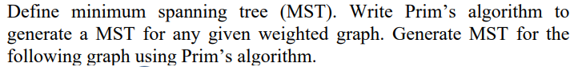 [10 Marks]

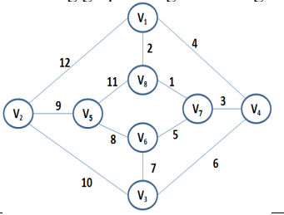

Q31. Explain Dijkstra’s algorithm to solve single source shortest path problem with suitable example. [10 Marks]

Q32. Discuss need of Huffman coding. What is an optimal Huffman code for the following set of frequencies? [10 Marks]

|  |  |  |  |  |  |  |  |
| --- | --- | --- | --- | --- | --- | --- | --- |
| Character | T | O | U | A | I | S | E |
| Frequency | 1 | 3 | 4 | 10 | 12 | 13 | 15 |

Q33. Define Task scheduling problem. Also find the optimal schedule for the following task with given weight (penalties) and deadlines. [10 Marks]

|  |  |  |  |  |  |  |  |
| --- | --- | --- | --- | --- | --- | --- | --- |
| **Task** | **1** | **2** | **3** | **4** | **5** | **6** | **7** |
| **di (Deadline)** | 4 | 2 | 4 | 3 | 1 | 4 | 6 |
| **wi (penality)** | 70 | 60 | 50 | 40 | 30 | 20 | 10 |

Q34. What is skip list? Explain the search operation in skip list with suitable example. Also write its algorithm. [10 Marks]

Q35. Differentiate between Divide and Conquer strategy and Greedy Approach. [5 Marks]

Q36. Discuss task scheduling problem with the help of greedy strategy and develop an algorithm to solve the following problem. We are given 9 tasks T1, T2,…T9. The execution of each task requires one unit time. We can execute one task at a time. Ti has a penalty Pi and a deadline Di. Penalty Pi is paid if task is not completed before the end of the Di unit of time. [10 Marks]

Task T1 T2 T3 T4 T5 T6 T7 T8 T9

Penalty 15 20 30 18 18 10 23 16 25

Deadline 7 2 5 3 4 5 2 7 3

Q37. Prove that if the weights on the edge of the connected undirected graph are distinct then there is a unique Minimum Spanning Tree. Give an example in this context. Also discuss Kruskal’s minimum spanning tree. [10 Marks]

Q38. What is the different Greedy criterion? Explain. Consider the five items along with their respective weights and values:

ITEM=(1,2,3,4,5) and WEIGHT=(5,10,20,30,40)

VALUE =(30,20,100,90,160)

The knapsack has capacity W=60. Find the solution of the problem using concept of fractional knapsack. [10 Marks]

Q39. What is the Negative Weights in the Graphs? What is the significance of Negative weight Cycles? [10 Marks]

Q40. Discuss about the Algorithm of Activity Selection Problem with an Example and Complexity. [10 Marks]

Q41. Solve This question using Stranssen”s Matrix Multiplication Method. [10 Marks]



Q42. Differentiate between Prim’s and Kruskal’s algorithm. Explain Prim’s Algorithm and find Minimum Spanning Tree of following graph. [10 Marks]

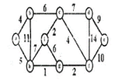

Q43. Consider the below graph: Apply Bellman ford algorithm to find the shortest path. [10 Marks]

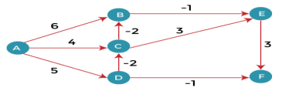

Q44. What are single source shortest path? Write down Dijkastra’s algorithm for it and compare it with Bellmen-ford algorithm. [10 Marks]

Q45.Construct the minimum spanning tree (MST) for the given graph using Prim’s Algorithm. [10 Marks]

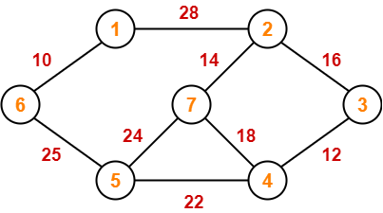

Q46. Construct the minimum spanning tree (MST) for the given graph using Kruskal Algorithm. [10 Marks]

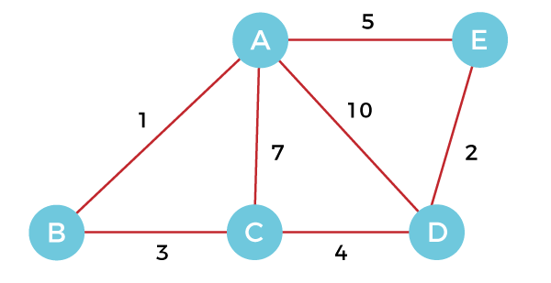

Q47. Using Dijkstra’s Algorithm, find the shortest distance from source vertex ‘S’ to remaining vertices in the following graph- [10 Marks]

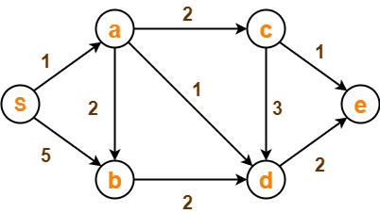

Q48. Using Bellman Ford Algorithm, find the shortest distance from source vertex ‘A’ to remaining vertices in the following graph- [10 Marks]

Bellman–Ford Algorithm Example Graph 1

Q49.

|  |
| --- |
| **Let G be any connected, weighted, undirected graph.**  **I. G has a unique minimum spanning tree if no two edges of G have the same weight.**  **II. G has a unique minimum spanning tree if, for every cut of G, there is a unique minimum-weight edge crossing the cut.**  **Which of the above two statements is/are TRUE?** |
| **I only** |
| **II only** |
| **Both I and II** |
| **Neither I nor II** |

Q50.

|  |  |
| --- | --- |
|  |  |